PHP Exercise 8

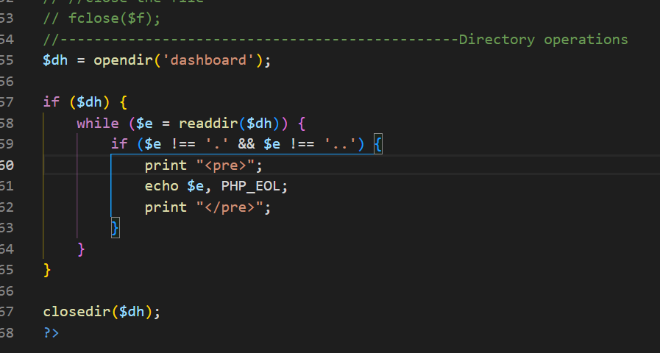

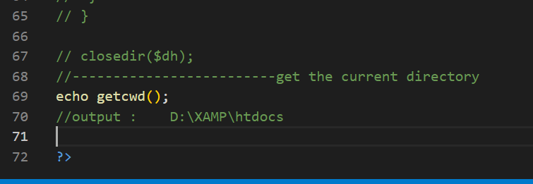

////

**Lets check dictory :**

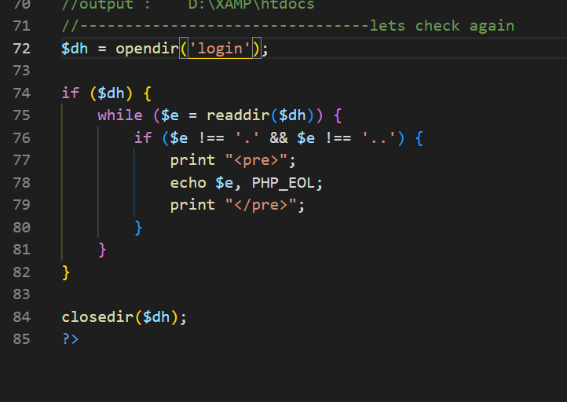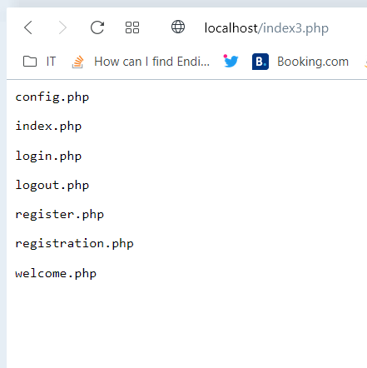

$dh = opendir('login');

if ($dh) {

    while ($e = readdir($dh)) {

        if ($e !== '.' && $e !== '..') {

            print "<pre>";

            echo $e, PHP_EOL;

            print "</pre>";

        }

    }

}

closedir($dh);

?>

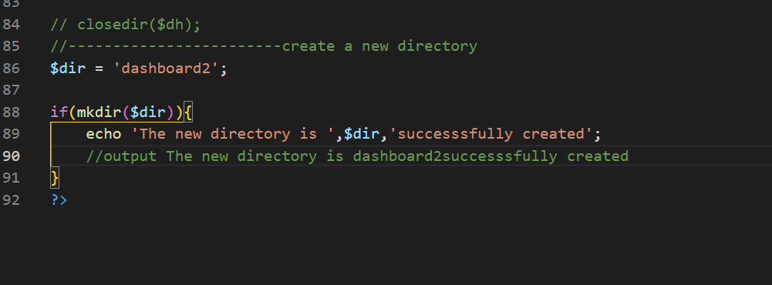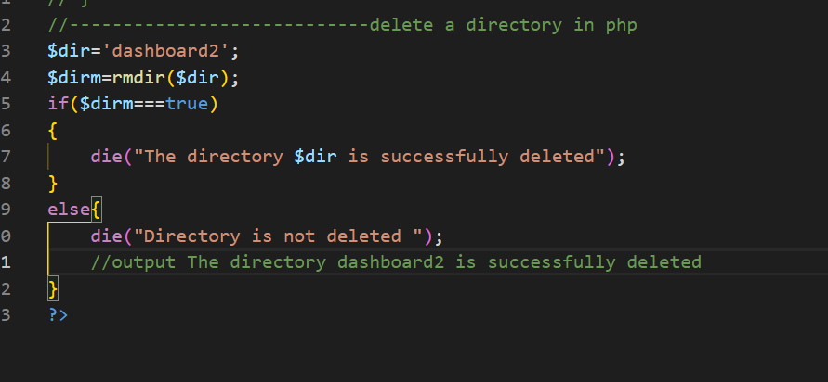

$dir='dashboard2';

$dirm=rmdir($dir);

if($dirm===true)

{

    die("The directory $dir is successfully deleted");

}

else{

    die("Directory is not deleted ");

    //output The directory dashboard2 is successfully deleted

}

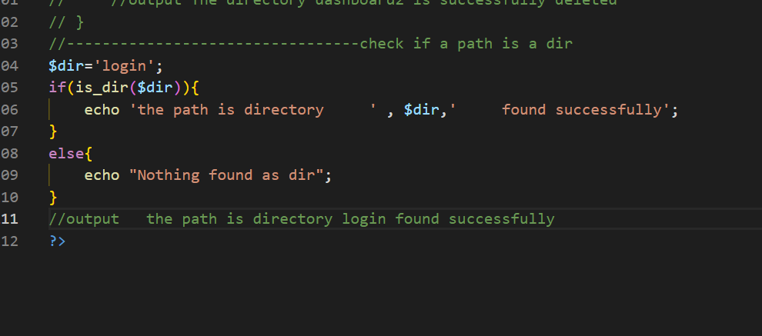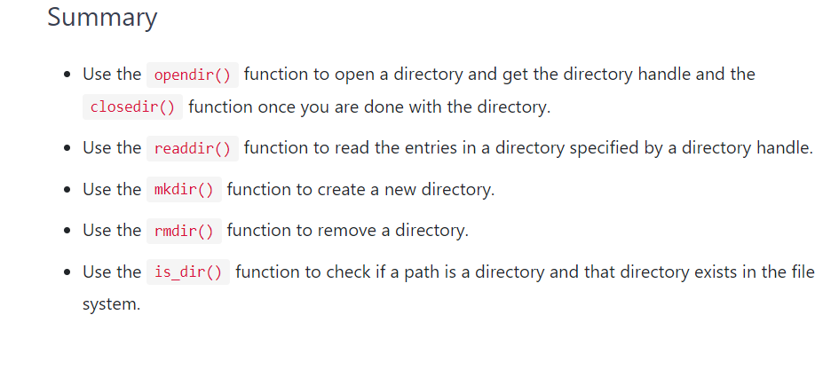

$dir='login';

if(is_dir($dir)){

    echo 'the path is directory     ' , $dir,'     found successfully';

}

else{

    echo "Nothing found as dir";

}

//output   the path is directory login found successfully

**Source code is :**

<?php

//how to read entire file in php

// $filename='data.csv';

// if(!is_readable($filename))

// {

//     die('the file is not opening '.$filename."");

// }

// print "<pre>";

// print_r(file_get_contents($filename)) ;

// print "</pre>";

//--------------------------------------------------writing and fputcvs() uses

// How to write a file and edit it

// $stock=[['symbol12','company11','peice13'],

// ['symbol2','company2','peice'],['symbol7','company7','peice7'],

// ['symbol3','company3','peice'],

// ['symbol4','company4','peice'],

// ['symbol5','company5','peice'],

// ['symbol6','company6','peice']];

// $f=fopen('data.csv','w');

// if($f===false)

// {

//     die("the file is not opening ".$f."");

// }

// foreach($stock as $stk)

// {

//     fputcsv($f,$stk);

// }

// fclose($f);

//---------------------------------------------------To verify the contents of data in data.csv file

// $filename='data.csv';

// if(!is_readable($filename))

// {

//     die('the file is not opening '.$filename."");

// }

// print "<pre>";

// print_r(file_get_contents($filename)) ;

// print "</pre>";

//------------------------------------------read csv file using fgetcsv()

// $filename='data.csv';

// $data=[];

// $f=fopen($filename,'r');

// if($f===false){

//     die('The file is not opening'.$filename);

// }

// //read eachline in csv file at a time

// while(($row=fgetcsv($f))!==false){

//     $data[]=$row;

//     print "<pre>";

// print_r ($data);

// print "</pre>";

// }

// //close the file

// fclose($f);

//-----------------------------------------------Directory operations

// $dh = opendir('htdocs');

// if ($dh) {

//  while ($e = readdir($dh)) {

//      if ($e !== '.' && $e !== '..') {

//             print "<pre>";

//             echo $e, PHP_EOL;

//             print "</pre>";

//      }

//  }

// }

// closedir($dh);

//-------------------------get the current directory

// echo getcwd();

//output :    D:\XAMP\htdocs

//--------------------------------lets check again

// $dh = opendir('login');

// if ($dh) {

//  while ($e = readdir($dh)) {

//      if ($e !== '.' && $e !== '..') {

//             print "<pre>";

//             echo $e, PHP_EOL;

//             print "</pre>";

//      }

//  }

// }

// closedir($dh);

//------------------------create a new directory

// $dir = 'dashboard2';

// if(mkdir($dir)){

//     echo 'The new directory is ',$dir,'successsfully created';

//     //output The new directory is dashboard2successsfully created

// }

//----------------------------delete a directory in php

// $dir='dashboard2';

// $dirm=rmdir($dir);

// if($dirm===true)

// {

//     die("The directory $dir is successfully deleted");

// }

// else{

//     die("Directory is not deleted ");

//     //output The directory dashboard2 is successfully deleted

// }

//---------------------------------check if a path is a dir

// $dir='login';

// if(is_dir($dir)){

//     echo 'the path is directory     ' , $dir,'     found successfully';

// }

// else{

//     echo "Nothing found as dir";

// }

// //output   the path is directory login found successfully

?>

The glob() function takes two parameters:

The $pattern is the pattern to match. To construct a pattern, you use the following special characters:

* Use * to match zero or more characters
* Use - to match exactly one character
* Use [] to match one character from a group of characters listed in the []. To negate the matching, you use the ! character as the first character in the group.
* Use \ to escape the following characters, except when the GLOB_NOESCAPE flag is set.

The $flag is one or more options that determine the behavior of the glob() function.

For example, if the $flag is GLOB_MARK, the glob() function adds a slash (/) or backslash (\) to each matching directory. For a complete list of valid flags, [check the glob() function](https://www.php.net/manual/en/function.glob.php" \t "https://www.phptutorial.net/php-tutorial/php-glob/_blank)

The glob() function returns an array that contains the matched files/directories.

If no files or directories match the pattern, the glob() function returns an empty array.

If an error occurs, the glob() function returns an false.

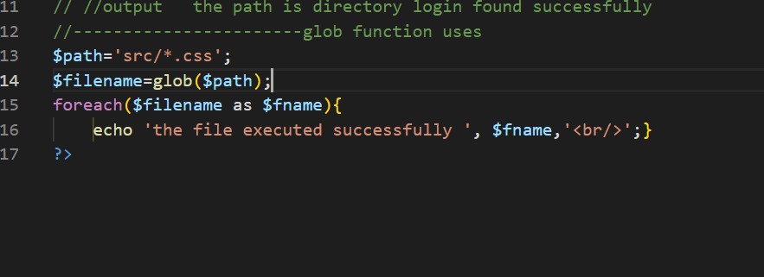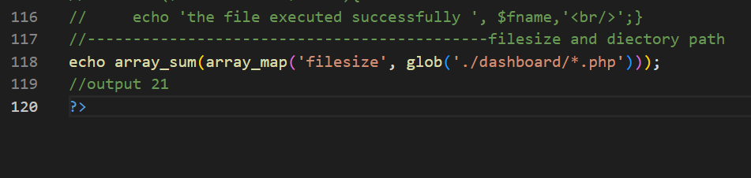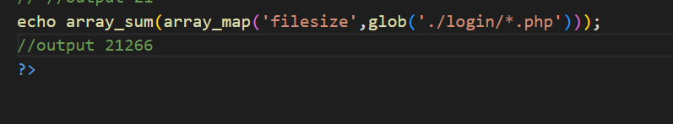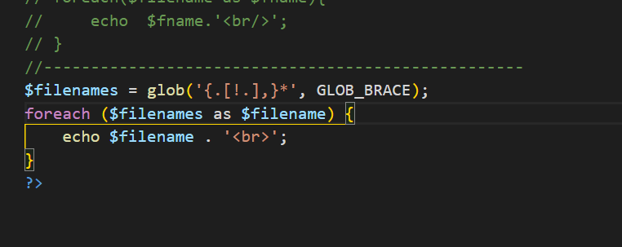

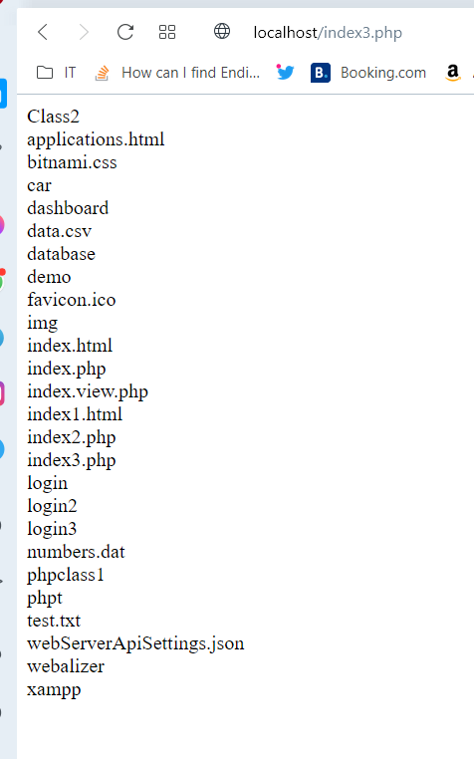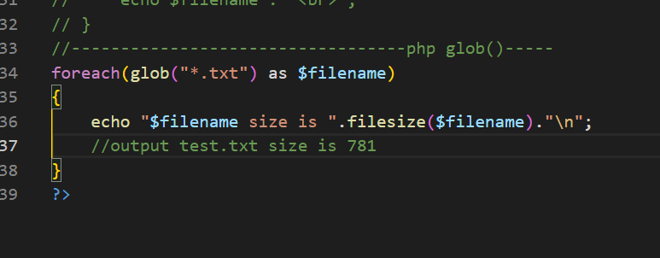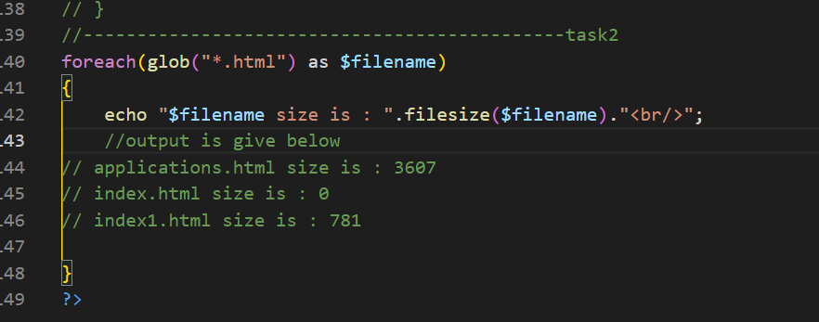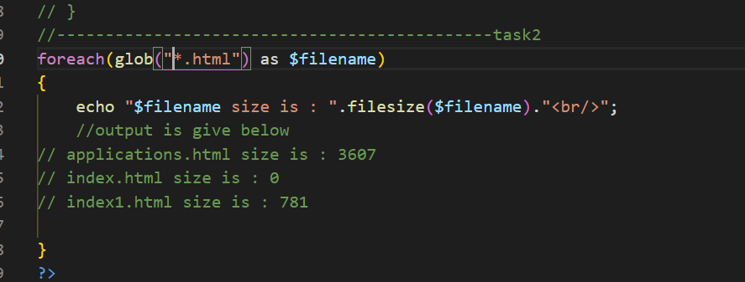

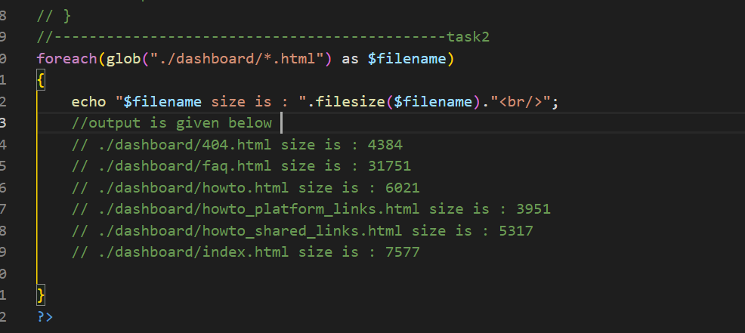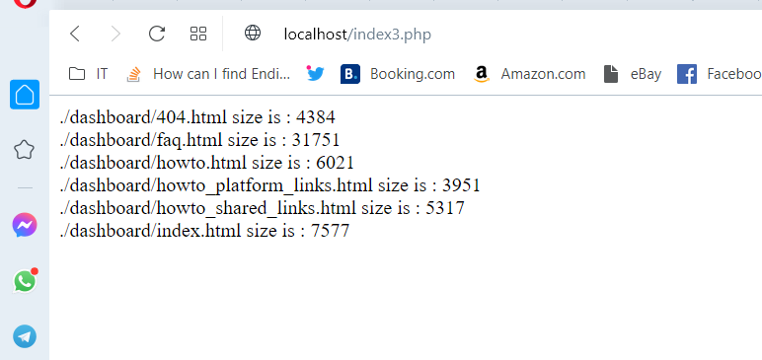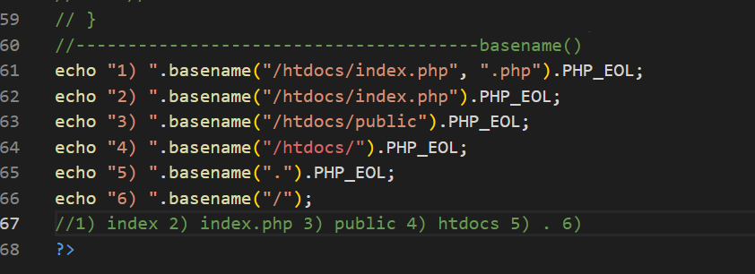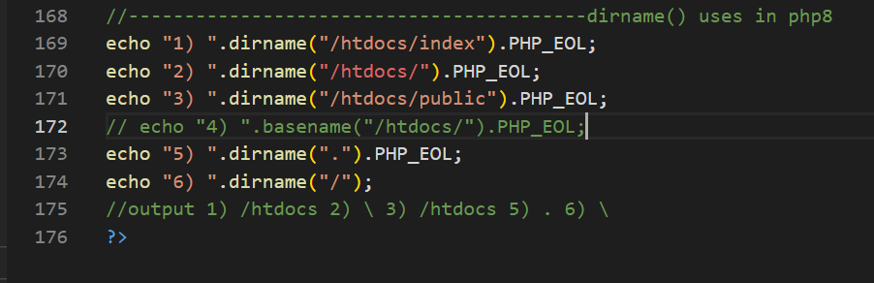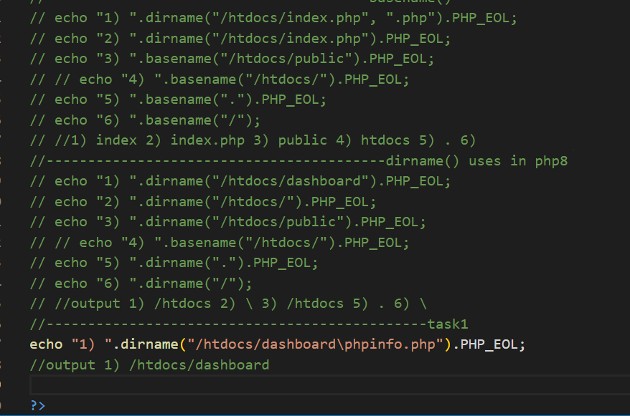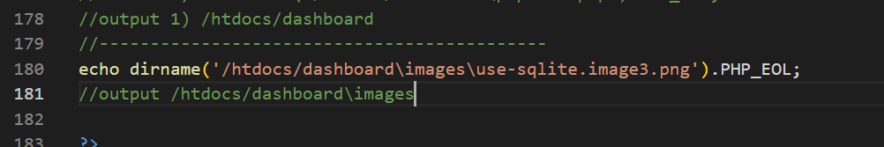

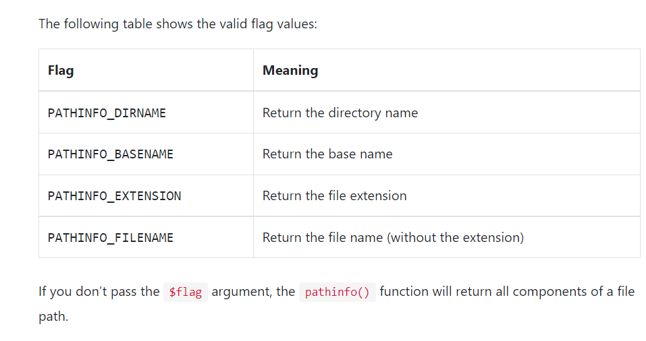

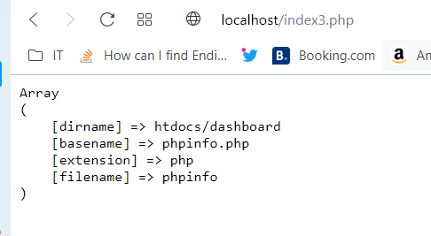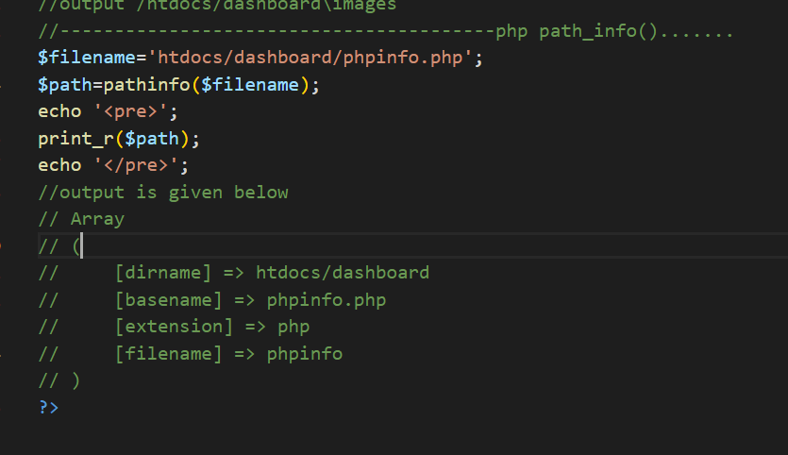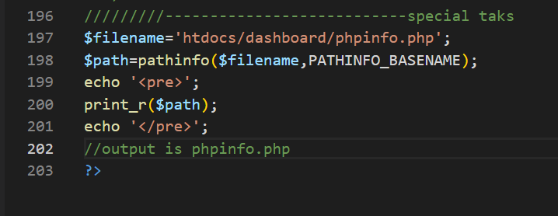

**Source code of filepath :**

<?php

//how to read entire file in php

// $filename='data.csv';

// if(!is_readable($filename))

// {

//     die('the file is not opening '.$filename."");

// }

// print "<pre>";

// print_r(file_get_contents($filename)) ;

// print "</pre>";

//--------------------------------------------------writing and fputcvs() uses

// How to write a file and edit it

// $stock=[['symbol12','company11','peice13'],

// ['symbol2','company2','peice'],['symbol7','company7','peice7'],

// ['symbol3','company3','peice'],

// ['symbol4','company4','peice'],

// ['symbol5','company5','peice'],

// ['symbol6','company6','peice']];

// $f=fopen('data.csv','w');

// if($f===false)

// {

//     die("the file is not opening ".$f."");

// }

// foreach($stock as $stk)

// {

//     fputcsv($f,$stk);

// }

// fclose($f);

//---------------------------------------------------To verify the contents of data in data.csv file

// $filename='data.csv';

// if(!is_readable($filename))

// {

//     die('the file is not opening '.$filename."");

// }

// print "<pre>";

// print_r(file_get_contents($filename)) ;

// print "</pre>";

//------------------------------------------read csv file using fgetcsv()

// $filename='data.csv';

// $data=[];

// $f=fopen($filename,'r');

// if($f===false){

//     die('The file is not opening'.$filename);

// }

// //read eachline in csv file at a time

// while(($row=fgetcsv($f))!==false){

//     $data[]=$row;

//     print "<pre>";

// print_r ($data);

// print "</pre>";

// }

// //close the file

// fclose($f);

//-----------------------------------------------Directory operations

// $dh = opendir('htdocs');

// if ($dh) {

//  while ($e = readdir($dh)) {

//      if ($e !== '.' && $e !== '..') {

//             print "<pre>";

//             echo $e, PHP_EOL;

//             print "</pre>";

//      }

//  }

// }

// closedir($dh);

//-------------------------get the current directory

// echo getcwd();

//output :    D:\XAMP\htdocs

//--------------------------------lets check again

// $dh = opendir('login');

// if ($dh) {

//  while ($e = readdir($dh)) {

//      if ($e !== '.' && $e !== '..') {

//             print "<pre>";

//             echo $e, PHP_EOL;

//             print "</pre>";

//      }

//  }

// }

// closedir($dh);

//------------------------create a new directory

// $dir = 'dashboard2';

// if(mkdir($dir)){

//     echo 'The new directory is ',$dir,'successsfully created';

//     //output The new directory is dashboard2successsfully created

// }

//----------------------------delete a directory in php

// $dir='dashboard2';

// $dirm=rmdir($dir);

// if($dirm===true)

// {

//     die("The directory $dir is successfully deleted");

// }

// else{

//     die("Directory is not deleted ");

//     //output The directory dashboard2 is successfully deleted

// }

//---------------------------------check if a path is a dir

// $dir='login';

// if(is_dir($dir)){

//     echo 'the path is directory     ' , $dir,'     found successfully';

// }

// else{

//     echo "Nothing found as dir";

// }

// //output   the path is directory login found successfully

//-----------------------glob function uses

// $path='./login/*.css';

// $filename=glob($path);

// foreach($filename as $fname){

//     echo 'the file executed successfully ', $fname,'<br/>';}

//--------------------------------------------filesize and diectory path

// echo array_sum(array_map('filesize', glob('./dashboard/*.php')));

// //output 21

// echo array_sum(array_map('filesize',glob('./login/*.php')));

//output 21266

//----------------------------------------check again

// $path='./login/*.css';

// $filename=glob($path);

// foreach($filename as $fname){

//     echo  $fname.'<br/>';

// }

//---------------------------------------------------

// $filenames = glob('{.[!.],}*', GLOB_BRACE);

// foreach ($filenames as $filename) {

//     echo $filename . '<br>';

// }

//----------------------------------php glob()-----

// foreach(glob("*.txt") as $filename)

// {

//     echo "$filename size is ".filesize($filename)."\n";

//     //output test.txt size is 781

// }

//---------------------------------------------task2

// foreach(glob("./dashboard/*.html") as $filename)

// {

//     echo "$filename size is : ".filesize($filename)."<br/>";

//     //output is given below

//     // ./dashboard/404.html size is : 4384

//     // ./dashboard/faq.html size is : 31751

//     // ./dashboard/howto.html size is : 6021

//     // ./dashboard/howto_platform_links.html size is : 3951

//     // ./dashboard/howto_shared_links.html size is : 5317

//     // ./dashboard/index.html size is : 7577

// }

///-----------------------------task3

// foreach(glob("*.html") as $filename)

// {

//     echo "$filename size is : ".filesize($filename)."<br/>";

//     //output is given below

//     // applications.html size is : 3607

//     // index.html size is : 0

//     // index1.html size is : 781

// }

//---------------------------------------basename()

// echo "1) ".dirname("/htdocs/index.php", ".php").PHP_EOL;

// echo "2) ".dirname("/htdocs/index.php").PHP_EOL;

// echo "3) ".basename("/htdocs/public").PHP_EOL;

// // echo "4) ".basename("/htdocs/").PHP_EOL;

// echo "5) ".basename(".").PHP_EOL;

// echo "6) ".basename("/");

// //1) index 2) index.php 3) public 4) htdocs 5) . 6)

//-----------------------------------------dirname() uses in php8

// echo "1) ".dirname("/htdocs/dashboard").PHP_EOL;

// echo "2) ".dirname("/htdocs/").PHP_EOL;

// echo "3) ".dirname("/htdocs/public").PHP_EOL;

// // echo "4) ".basename("/htdocs/").PHP_EOL;

// echo "5) ".dirname(".").PHP_EOL;

// echo "6) ".dirname("/");

// //output 1) /htdocs 2) \ 3) /htdocs 5) . 6) \

//----------------------------------------------task1

// echo "1) ".dirname("/htdocs/dashboard\phpinfo.php").PHP_EOL;

//output 1) /htdocs/dashboard

//--------------------------------------------

// echo dirname('/htdocs/dashboard\images\use-sqlite.image3.png').PHP_EOL;

//output /htdocs/dashboard\images

//----------------------------------------php path_info().......

// $filename='htdocs/dashboard/phpinfo.php';

// $path=pathinfo($filename);

// echo '<pre>';

// print_r($path);

// echo '</pre>';

//output is given below

// Array

// (

//     [dirname] => htdocs/dashboard

//     [basename] => phpinfo.php

//     [extension] => php

//     [filename] => phpinfo

// )

/////////---------------------------special taks

// $filename='htdocs/dashboard/phpinfo.php';

// $path=pathinfo($filename,PATHINFO_BASENAME);

// echo '<pre>';

// print_r($path);

// echo '</pre>';

//output is phpinfo.php

?>

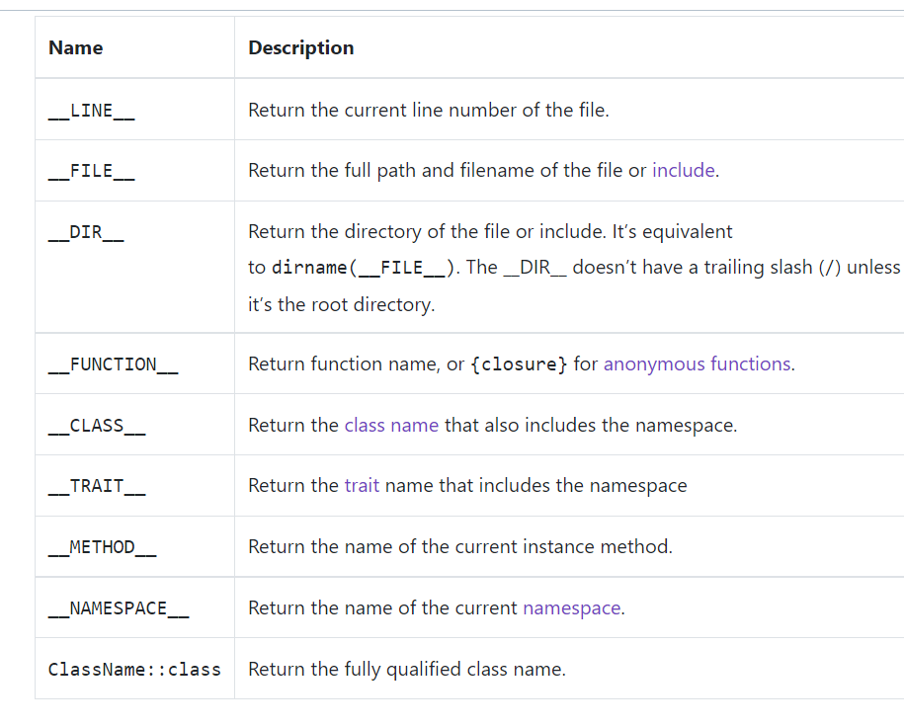

namespace App;

class HttpRequest

{

    public function __construct()

    {

        echo 'The current class name is ' .  __CLASS__ . '<br>';

    }

    public function isPost()

    {

        echo 'The current method is ' . __METHOD__ . '<br>';

        return $_SERVER['REQUEST_METHOD'];

    }

}

$request = new HttpRequest();

$request->isPost();

echo 'The current namespace is ' . __NAMESPACE__ . '<br>';

echo 'The fully qualified class name is '  . HttpRequest::class . '<br>';

echo 'The current file is ' . __FILE__ . '<br>';

echo 'The current line is ' . __LINE__ . '<br>';

echo 'The current directory is ' . __DIR__  . '<br>';

